

Dental Board of Australia

Registrant Data

Reporting period: 1 July 2016 – 30 September 2016

Table of contents

1. Registration type 4
2. Registration divisions 5
3. Registration type and divisions 6
5. Dental specialties 8
6. Endorsements 8
7. Age group 9
8. Gender 10

Introduction
The functions of the Dental Board of Australia (the Board) include:
- registering dentists, students, dental specialists, dental therapists, dental hygienists, oral health therapists and dental prosthetists
- developing standards, codes and guidelines for the dental profession
- handling notifications, complaints, investigations and disciplinary hearings
- overseeing the assessment of overseas trained practitioners who wish to practise in Australia, and
- approving accreditation standards and accredited courses of study.
The Board’s functions are supported by the Australian Health Practitioner Regulation Agency (AHPRA). For information about legislation governing our operations see AHPRA's Legislation & Publications at www.ahpra.gov.au/Publications
The Board has analysed its registration data and produced a number of statistical breakdowns about registrants to share with the profession and community. The Board shares these breakdowns regularly.
For more information on dental registration, please see the Board’s website: http://www.dentalboard.gov.au/Registration.aspx

- Registration type
  - Dental practitioners - registration type by state or territory
Registration Type | Registration Sub-type | ACT | NSW | NT | QLD | SA | TAS | VIC | WA | No PPP | Total
General |  | 356 | 5,954 | 144 | 3,924 | 1,596 | 329 | 4,471 | 2,330 | 424 | 19,528
General and Specialist |  | 37 | 481 | 3 | 321 | 144 | 26 | 403 | 175 | 48 | 1,638
General and Non-practising |  |  |  |  | 1 |  |  |  |  |  | 1
Specialist |  | 2 | 4 | 2 | 2 | 4 |  | 8 | 4 | 6 | 32
Limited | Postgraduate training or supervised practice | 1 | 4 |  | 2 | 12 |  | 6 | 1 |  | 26
Limited | Public interest
Limited | Teaching or research |  | 12 |  | 19 | 9 |  | 5 | 1 |  | 46
Non-practising |  | 5 | 141 | 3 | 67 | 30 | 4 | 112 | 51 | 126 | 539
Total |  | 401 | 6,596 | 152 | 4,336 | 1,795 | 359 | 5,005 | 2,562 | 604 | 21,810

  - Dental practitioners - percentage by principal place of practice
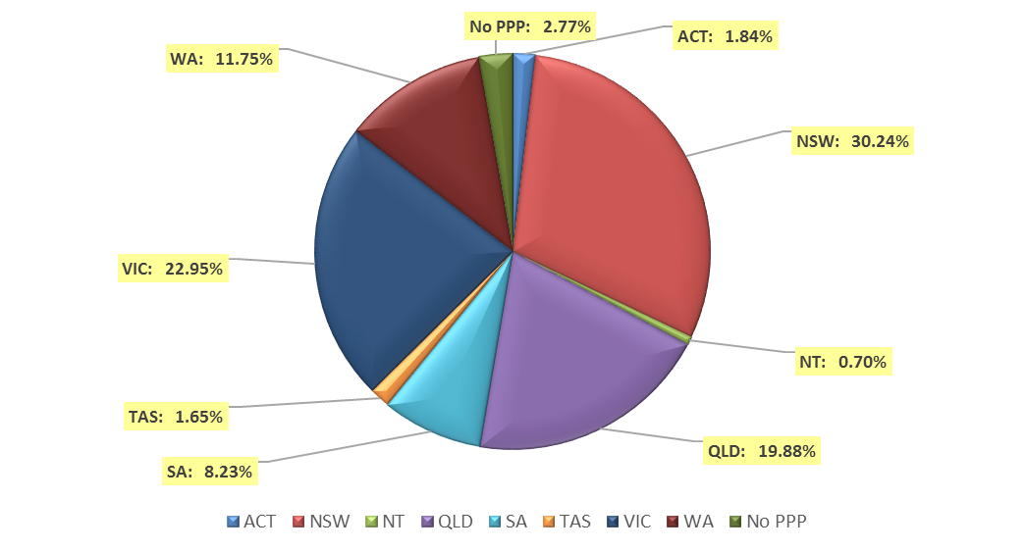

- Registration divisions
  - Dental practitioners - division(s) by state or territory
Divisions | ACT | NSW | NT | QLD | SA | TAS | VIC | WA | No PPP | Total
Dental Hygienist | 43 | 429 | 13 | 138 | 259 | 18 | 220 | 270 | 30 | 1,420
Dental Hygienist and Dental Prosthetist |  | 2 |  | 1 |  |  |  |  |  | 3
Dental Hygienist and Dental Prosthetist and Dental Therapist |  | 1 |  |  |  |  | 1 |  |  | 2
Dental Hygienist and Dental Therapist | 11 | 65 | 7 | 144 | 61 | 2 | 126 | 54 | 9 | 479
Dental Hygienist and Dental Therapist and Dentist |  |  |  | 2 |  |  |  |  |  | 2
Dental Hygienist and Dental Therapist and Oral Health Therapist |  |  |  | 3 |  |  |  |  |  | 3
Dental Hygienist and Dentist |  | 2 |  | 1 |  |  |  |  |  | 3
Dental Hygienist and Oral Health Therapist |  | 2 |  |  | 1 |  |  | 3 |  | 6
Dental Prosthetist | 16 | 411 | 4 | 271 | 64 | 48 | 352 | 86 | 3 | 1,255
Dental Prosthetist and Dental Therapist |  |  |  |  |  |  | 1 |  |  | 1
Dental Prosthetist and Dentist |  |  |  |  |  |  | 2 |  |  | 2
Dental Therapist | 18 | 212 | 15 | 181 | 85 | 48 | 159 | 289 | 10 | 1,017
Dental Therapist and Dentist |  |  |  |  |  |  | 1 |  |  | 1
Dental Therapist and Oral Health Therapist |  |  |  |  |  |  |  | 4 |  | 4
Dentist | 293 | 5,142 | 105 | 3,235 | 1,167 | 231 | 3,826 | 1,749 | 547 | 16,295
Dentist and Oral Health Therapist |  | 1 |  |  | 1 |  |  |  |  | 2
Oral Health Therapist | 20 | 329 | 8 | 360 | 157 | 12 | 317 | 107 | 5 | 1,315
Total | 401 | 6,596 | 152 | 4,336 | 1,795 | 359 | 5,005 | 2,562 | 604 | 21,810

- Registration type and divisions
  - Dental practitioners – registration type and division by state or territory
Registration Type | Divisions | ACT | NSW | NT | QLD | SA | TAS | VIC | WA | No PPP | Total
General | Dental Hygienist | 42 | 420 | 13 | 137 | 252 | 18 | 216 | 260 | 23 | 1,381
General | Dental Hygienist and Dental Prosthetist |  | 2 |  | 1 |  |  |  |  |  | 3
General | Dental Hygienist and Dental Prosthetist and Dental Therapist |  | 1 |  |  |  |  | 1 |  |  | 2
General | Dental Hygienist and Dental Therapist | 11 | 63 | 6 | 143 | 61 | 2 | 123 | 53 | 9 | 471
General | Dental Hygienist and Dental Therapist and Dentist |  |  |  | 2 |  |  |  |  |  | 2
General | Dental Hygienist and Dental Therapist and Oral Health Therapist |  |  |  | 3 |  |  |  |  |  | 3
General | Dental Hygienist and Dentist |  | 2 |  |  |  |  |  |  |  | 2
General | Dental Hygienist and Oral Health Therapist |  | 2 |  |  | 1 |  |  | 3 |  | 6
General | Dental Prosthetist | 16 | 399 | 4 | 267 | 64 | 47 | 342 | 83 | 1 | 1,223
General | Dental Prosthetist and Dental Therapist |  |  |  |  |  |  | 1 |  |  | 1
General | Dental Prosthetist and Dentist |  |  |  |  |  |  | 2 |  |  | 2
General | Dental Therapist | 18 | 201 | 15 | 176 | 83 | 47 | 152 | 279 | 9 | 980
General | Dental Therapist and Dentist |  |  |  |  |  |  | 1 |  |  | 1
General | Dental Therapist and Oral Health Therapist |  |  |  |  |  |  |  | 4 |  | 4
General | Dentist | 249 | 4,537 | 98 | 2,844 | 979 | 203 | 3,319 | 1,543 | 378 | 14,150
General | Dentist and Oral Health Therapist |  | 1 |  |  | 1 |  |  |  |  | 2
General | Oral Health Therapist | 20 | 326 | 8 | 351 | 155 | 12 | 314 | 105 | 4 | 1,295
Sub Total |  | 356 | 5,954 | 144 | 3,924 | 1,596 | 329 | 4,471 | 2,330 | 424 | 19,528
General and Specialist | Dentist | 37 | 481 | 3 | 321 | 144 | 26 | 403 | 175 | 48 | 1,638
Specialist | Dentist | 2 | 4 | 2 | 2 | 4 |  | 8 | 4 | 6 | 32
Limited | Dental Hygienist |  | 1 |  |  |  |  |  |  |  | 1
Limited | Dentist | 1 | 15 |  | 21 | 21 |  | 10 | 2 |  | 70
Limited | Oral Health Therapist |  |  |  |  |  |  | 1 |  |  | 1
Sub Total |  | 40 | 501 | 5 | 344 | 169 | 26 | 422 | 181 | 54 | 1,742
Continued on next page

Registration Type | Divisions | ACT | NSW | NT | QLD | SA | TAS | VIC | WA | No PPP | Total
General and Non-practising | Dental Hygienist and Dentist |  |  |  | 1 |  |  |  |  |  | 1
Non-practising | Dental Hygienist | 1 | 8 |  | 1 | 7 |  | 4 | 10 | 7 | 38
Non-practising | Dental Hygienist and Dental Therapist |  | 2 | 1 | 1 |  |  | 3 | 1 |  | 8
Non-practising | Dental Prosthetist |  | 12 |  | 4 |  | 1 | 10 | 3 | 2 | 32
Non-practising | Dental Therapist |  | 11 |  | 5 | 2 | 1 | 7 | 10 | 1 | 37
Non-practising | Dentist | 4 | 105 | 2 | 47 | 19 | 2 | 86 | 25 | 115 | 405
Non-practising | Oral Health Therapist |  | 3 |  | 9 | 2 |  | 2 | 2 | 1 | 19
Sub Total |  | 5 | 141 | 3 | 68 | 30 | 4 | 112 | 51 | 126 | 540
Total |  | 401 | 6,596 | 152 | 4,336 | 1,795 | 359 | 5,005 | 2,562 | 604 | 21,810

- Dental specialties
  - Dental practitioners – dental speciality by state or territory
Specialty | ACT | NSW | NT | QLD | SA | TAS | VIC | WA | No PPP | Total
Dento-maxillofacial radiology |  |  |  | 6 |  |  | 1 | 3 |  | 10
Endodontics | 7 | 49 | 1 | 29 | 15 | 3 | 39 | 16 | 5 | 164
Forensic odontology | 2 | 6 | 1 | 2 | 3 | 2 | 5 | 5 |  | 26
Oral and maxillofacial surgery | 3 | 53 | 1 | 44 | 17 | 5 | 51 | 22 | 7 | 203
Oral medicine |  | 7 |  | 5 |  |  | 12 | 8 | 3 | 35
Oral pathology |  | 7 |  | 4 | 3 |  | 4 | 4 | 2 | 24
Oral surgery |  | 38 |  | 4 |  |  | 7 | 2 | 1 | 52
Orthodontics | 11 | 187 | 3 | 127 | 55 | 13 | 138 | 54 | 20 | 608
Paediatric dentistry | 2 | 36 |  | 22 | 13 |  | 36 | 15 | 6 | 130
Periodontics | 9 | 59 |  | 42 | 16 | 3 | 57 | 32 | 6 | 224
Prosthodontics | 5 | 65 |  | 43 | 22 |  | 54 | 21 | 4 | 214
Public health dentistry (Community dentistry) |  | 3 |  | 1 | 2 |  | 8 | 1 | 1 | 16
Special needs dentistry |  | 2 |  | 4 | 2 |  | 7 |  | 1 | 16
Total | 39 | 512 | 6 | 333 | 148 | 26 | 419 | 183 | 56 | 1,722

- Endorsements
  - Dental practitioners – endorsements by state or territory
Endorsement | ACT | NSW | NT | QLD | SA | TAS | VIC | WA | No PPP | Total
Area of Practice – conscious sedation | 4 | 50 | 2 | 22 | 2 | 2 | 5 | 9 |  | 96

- Age group
  - Dental practitioners – by age group
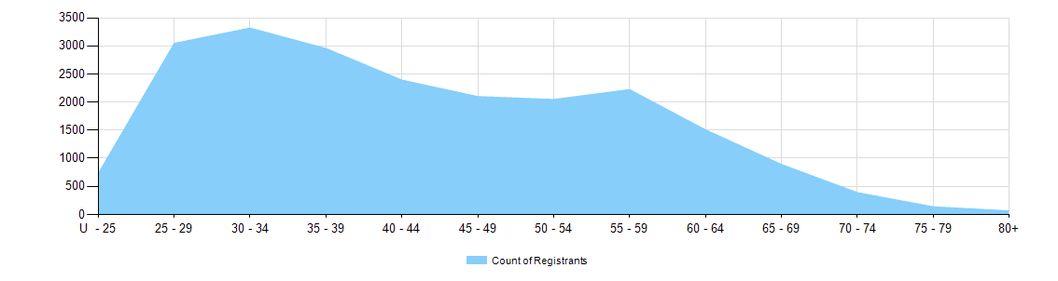

  - Dental practitioners – registration type by age group
Age Group | General | General and Specialist | Specialist | Limited |  |  | General and Non-practising | Non-practising | Total
 |  |  |  | Postgraduate training or supervised practice | Public interest | Teaching or research | General and Non-practising | Non-practising | Total
U - 25 | 727 |  |  |  |  |  |  | 4 | 731
25 - 29 | 2,989 | 4 |  | 11 |  | 1 |  | 41 | 3,046
30 - 34 | 3,107 | 121 | 4 | 12 |  | 6 | 1 | 69 | 3,320
35 - 39 | 2,595 | 274 | 15 | 2 |  | 11 |  | 59 | 2,956
40 - 44 | 2,119 | 211 | 4 | 1 |  | 10 |  | 48 | 2,393
45 - 49 | 1,854 | 184 | 7 |  |  | 6 |  | 48 | 2,099
50 - 54 | 1,798 | 201 | 1 |  |  | 7 |  | 41 | 2,048
55 - 59 | 1,926 | 235 |  |  |  | 2 |  | 61 | 2,224
60 - 64 | 1,263 | 185 |  |  |  | 2 |  | 58 | 1,508
65 - 69 | 724 | 124 | 1 |  |  |  |  | 43 | 892
70 - 74 | 291 | 62 |  |  |  | 1 |  | 36 | 390
75 - 79 | 101 | 25 |  |  |  |  |  | 12 | 138
80+ | 34 | 12 |  |  |  |  |  | 19 | 65
Total | 19,528 | 1,638 | 32 | 26 |  | 46 | 1 | 539 | 21,810

- Gender
  - Dental practitioners – registration type by gender
Gender | Registration Type | ACT | NSW | NT | QLD | SA | TAS | VIC | WA | No PPP | Total
Female | General | 218 | 2,802 | 77 | 1,961 | 932 | 155 | 2,334 | 1,374 | 189 | 10,042
Female | General and Specialist | 6 | 114 |  | 71 | 40 | 6 | 125 | 45 | 11 | 418
Female | Specialist |  | 2 | 1 |  | 1 |  | 5 | 2 |  | 11
Female | Limited |  | 10 |  | 8 | 11 |  | 4 | 2 |  | 35
Female | Non-practising | 4 | 67 | 2 | 40 | 16 | 2 | 52 | 33 | 61 | 277
Female | General and Non-practising |  |  |  | 1 |  |  |  |  |  | 1
Total Female |  | 228 | 2,995 | 80 | 2,081 | 1,000 | 163 | 2,520 | 1,456 | 261 | 10,784
Male | General | 138 | 3,152 | 67 | 1,963 | 664 | 174 | 2,137 | 956 | 235 | 9,486
Male | General and Specialist | 31 | 367 | 3 | 250 | 104 | 20 | 278 | 130 | 37 | 1,220
Male | Specialist | 2 | 2 | 1 | 2 | 3 |  | 3 | 2 | 6 | 21
Male | Limited | 1 | 6 |  | 13 | 10 |  | 7 |  |  | 37
Male | Non-practising | 1 | 74 | 1 | 27 | 14 | 2 | 60 | 18 | 65 | 262
Total Male |  | 173 | 3,601 | 72 | 2,255 | 795 | 196 | 2,485 | 1,106 | 343 | 11,026
Total |  | 401 | 6,596 | 152 | 4,336 | 1,795 | 359 | 5,005 | 2,562 | 604 | 21,810

  - Dental practitioners – percentage by gender
Gender | ACT | NSW | NT | QLD | SA | TAS | VIC | WA | No PPP | Total
Female | 56.9% | 45.4% | 52.6% | 48% | 55.7% | 45.4% | 50.3% | 56.8% | 43.2% | 49.4%
Male | 43.1% | 54.6% | 47.4% | 52% | 44.3% | 54.6% | 49.7% | 43.2% | 56.8% | 50.6%

