Dental Practitioner Registrant Data: March 2013

Published April 2013
Introduction
The functions of the Dental Board of Australia include:
- registering dentists, students, dental specialists, dental therapists, dental hygienists, oral health therapists and dental prosthetists
- developing standards, codes and guidelines for the dental profession
- handling notifications, complaints, investigations and disciplinary hearings
- assessing overseas trained practitioners who wish to practise in Australia
- approving accreditation standards and accredited courses of study.

The Board’s functions are supported by Australian Health Practitioner Regulation Agency (AHPRA). For information about legislation governing our operations see AHPRA's Legislation & Publications at www.ahpra.gov.au/Legislation-and-Publications.aspx

The Board has analysed its registration data and produced a number of statistical breakdowns about registrants to share with the profession and community. The Board shares these breakdowns regularly.

For more information on dental registration, please see the Board’s website:
http://www.dentalboard.gov.au/Registration.aspx

Index of Tables
Dental practitioners: State and territory by registration type 2
Dental practitioners: Age by registration type 3
Dental practitioners: Gender by state and territory by registration type 4
Dental practitioners: Endorsement type by state and territory 4
Dental practitioners: Registration numbers by division by state and territory 4

Dental practitioners: State and territory by registration type
State | General | General and Specialist | Limited |  |  | Non-practising | Specialist | Total | % By State
 |  |  | Postgraduate training or supervised practice | Public interest | Teaching or research
ACT | 314 | 40 |  |  |  | 6 |  | 360 | 1.83%
NSW | 5,493 | 455 | 87 | 1 | 8 | 101 | 8 | 6,153 | 30.93%
NT | 131 | 7 |  |  |  | 1 | 1 | 140 | 0.69%
QLD | 3,452 | 301 | 34 |  | 16 | 44 | 1 | 3,848 | 19.46%
SA | 1,461 | 136 | 31 |  | 12 | 14 | 3 | 1,657 | 8.43%
TAS | 303 | 22 | 2 |  |  | 4 |  | 331 | 1.71%
VIC | 3,930 | 373 | 116 |  | 6 | 100 | 8 | 4,533 | 22.82%
WA | 2,060 | 151 | 30 |  | 1 | 57 | 2 | 2,301 | 11.75%
Not Stated | 350 | 36 | 5 |  |  | 52 | 3 | 446 | 2.39%
Total | 17,494 | 1,521 | 305 | 1 | 43 | 379 | 26 | 19,769

% By state and territory
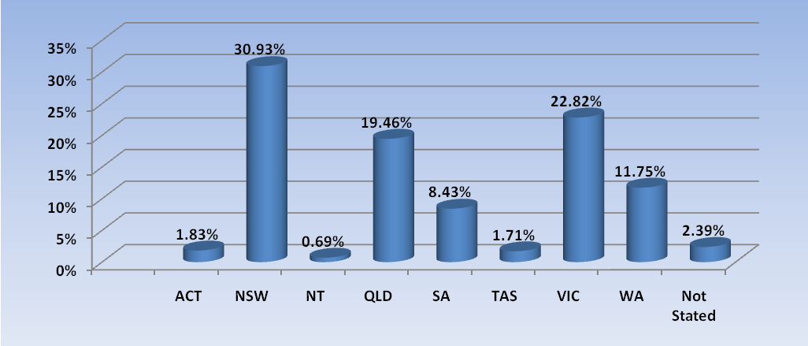

Dental practitioners: Age by registration type
Age Group | General | General and Specialist | Specialist | Limited |  |  | Non-practising | Total | % By Age Group
 |  |  |  | Postgraduate training or supervised practice | Public interest | Teaching or research
21 - 25 | 1,056 |  |  |  |  |  | 7 | 1,063 | 5.38%
26 - 30 | 2,528 | 17 | 1 | 108 |  | 1 | 36 | 2,691 | 13.61%
31 - 35 | 2,585 | 173 | 8 | 124 |  | 11 | 49 | 2,950 | 14.92%
36 - 40 | 2,061 | 178 | 8 | 45 |  | 8 | 43 | 2,343 | 11.85%
41 - 45 | 1,932 | 196 | 4 | 20 |  | 5 | 34 | 2,191 | 11.08%
46 - 50 | 1,773 | 192 | 2 | 5 |  | 8 | 37 | 2,017 | 10.20%
51 - 55 | 1,997 | 221 | 1 |  | 1 | 5 | 35 | 2,260 | 11.43%
56 - 60 | 1,639 | 219 |  | 3 |  | 2 | 36 | 1,899 | 9.61%
61 - 65 | 1,028 | 155 | 1 |  |  | 2 | 34 | 1,220 | 6.17%
66 - 70 | 564 | 105 |  |  |  |  | 30 | 699 | 3.54%
71 - 75 | 206 | 36 |  |  |  | 1 | 17 | 260 | 1.32%
76 - 80 | 79 | 24 | 1 |  |  |  | 8 | 112 | 0.57%
81 - 85 | 25 | 3 |  |  |  |  | 9 | 37 | 0.19%
86 + | 7 | 2 |  |  |  |  | 4 | 13 | 0.07%
Not Stated | 14 |  |  |  |  |  |  | 14 | 0.07%
Total | 17,494 | 1,521 | 26 | 305 | 1 | 43 | 379 | 19,769

% by age group

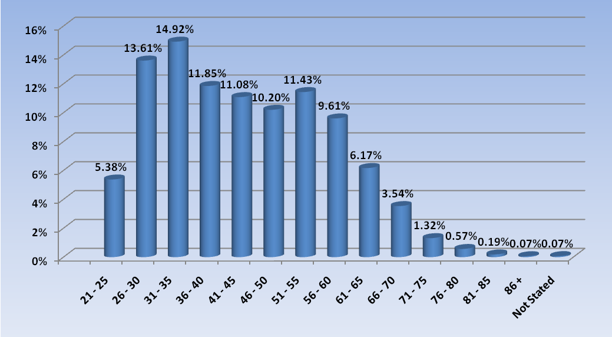

Dental practitioners: Gender by state/territory by registration type
Sex | State | General | General and Specialist | Specialist | Limited |  |  | Non-practising | Total Count | % By Sex By State
 |  |  |  |  | Postgraduate training or supervised practice | Public interest | Teaching or research
Female | ACT | 172 | 4 |  |  |  |  | 4 | 180 | 0.91%
 | NSW | 2,421 | 100 | 3 | 50 |  | 5 | 54 | 2,633 | 13.32%
 | NT | 72 | 1 |  |  |  |  |  | 73 | 0.37%
 | QLD | 1,653 | 64 |  | 20 |  | 5 | 23 | 1,765 | 8.93%
 | SA | 797 | 34 | 1 | 16 |  | 7 | 8 | 863 | 4.37%
 | TAS | 65 | 1 |  |  |  |  | 3 | 69 | 0.35%
 | VIC | 1,915 | 102 | 5 | 83 |  | 3 | 48 | 2,156 | 10.91%
 | WA | 1,159 | 35 | 1 | 24 |  | 1 | 42 | 1,262 | 6.38%
 | Not Stated | 127 | 8 |  | 3 |  |  | 27 | 165 | 0.83%
 | Sub total | 8,381 | 349 | 10 | 196 |  | 21 | 209 | 9,166 | 46.37%
Male | ACT | 142 | 36 |  |  |  |  | 2 | 180 | 0.91%
 | NSW | 3,056 | 354 | 5 | 37 | 1 | 3 | 47 | 3,503 | 17.72%
 | NT | 59 | 6 | 1 |  |  |  | 1 | 67 | 0.34%
 | QLD | 1,796 | 237 | 1 | 14 |  | 11 | 21 | 2,080 | 10.52%
 | SA | 636 | 102 | 2 | 15 |  | 5 | 6 | 766 | 3.87%
 | TAS | 174 | 19 |  | 2 |  |  | 1 | 196 | 0.99%
 | VIC | 2,009 | 271 | 3 | 33 |  | 3 | 52 | 2,371 | 11.99%
 | WA | 845 | 111 | 1 | 6 |  |  | 14 | 977 | 4.94%
 | Not Stated | 218 | 28 | 3 | 2 |  |  | 24 | 275 | 1.39%
 | Sub total | 8,935 | 1,164 | 16 | 109 | 1 | 22 | 168 | 10,415 | 52.68%
Not Stated | NSW | 16 | 1 |  |  |  |  |  | 17 | 0.09%
 | QLD | 3 |  |  |  |  |  |  | 3 | 0.02%
 | SA | 28 |  |  |  |  |  |  | 28 | 0.14%
 | TAS | 64 | 2 |  |  |  |  |  | 66 | 0.33%
 | VIC | 6 |  |  |  |  |  |  | 6 | 0.03%
 | WA | 56 | 5 |  |  |  |  | 1 | 62 | 0.31%
 | Not Stated | 5 |  |  |  |  |  | 1 | 6 | 0.03%
 | Sub total | 178 | 8 |  |  |  |  | 2 | 188 | 0.95%
Total |  | 17,494 | 1,521 | 26 | 305 | 1 | 43 | 379 | 19,769

Dental practitioners: Endorsement type by state and territory
Dental Practitioners | ACT | NSW | NT | QLD | SA | TAS | VIC | WA | No PPP | Grand Total
Endorsed conscious sedation practitioner | 4 | 56 | 3 | 16 | 1 | 2 | 5 | 8 | 1 | 96

Dental practitioners: Registration numbers by division by state/territory
Division | ACT | NSW | NT | QLD | SA | TAS | VIC | WA | No PPP | Grand Total
Dental Hygienist | 42 | 365 | 8 | 126 | 234 | 17 | 178 | 285 | 12 | 1,267
Dental Hygienist and Dental Prosthetist |  | 1 |  | 1 |  |  |  |  |  | 2
Dental Hygienist and Dental Prosthetist and Dental Therapist |  | 1 |  |  |  |  | 1 |  |  | 2
Dental Hygienist and Dental Therapist | 10 | 60 | 7 | 169 | 67 | 1 | 135 | 51 | 1 | 501
Dental Hygienist and Dentist | 1 |  |  |  |  |  |  |  |  | 1
Dental Prosthetist | 14 | 416 | 5 | 224 | 53 | 50 | 335 | 88 | 4 | 1,189
Dental Therapist | 16 | 236 | 18 | 209 | 97 | 52 | 173 | 333 | 1 | 1,135
Dental Therapist and Dentist |  | 1 |  |  |  |  |  |  |  | 1
Dentist | 270 | 4,885 | 98 | 2,840 | 1,120 | 206 | 3,622 | 1,551 | 298 | 14,890
Oral Health Therapist | 9 | 207 | 5 | 291 | 91 | 5 | 162 | 10 | 1 | 781
Grand Total | 362 | 6,172 | 141 | 3,860 | 1,662 | 331 | 4,606 | 2,318 | 317 | 19,769

