

Dental Board of Australia

Registrant data

Reporting period: 1 January 2018 – 31 March 2018

Table of contents
Introduction 3
Registration type 4
Registration divisions 5
Registration type and divisions 6
Dental specialties 8
Endorsements 8
Age group 9
Gender 10

Introduction
The functions of the Dental Board of Australia (the Board) include:
- registering dentists, students, dental specialists, dental therapists, dental hygienists, oral health therapists and dental prosthetists
- developing standards, codes and guidelines for the dental profession
- handling notifications, complaints, investigations and disciplinary hearings
- overseeing the assessment of overseas trained practitioners who wish to practise in Australia, and
- approving accreditation standards and accredited courses of study.
The Board’s functions are supported by the Australian Health Practitioner Regulation Agency (AHPRA). For information about legislation governing our operations see AHPRA's Legislation & Publications at www.ahpra.gov.au/Publications
The Board has analysed its registration data and produced a number of statistical breakdowns about registrants to share with the profession and community. The Board shares these breakdowns regularly.
For more information on dental registration, please see the Board’s website: www.dentalboard.gov.au/Registration.aspx

Registration type
  - Dental practitioners – registration type by state or territory
Registration type | Registration subtype | ACT | NSW | NT | QLD | SA | TAS | VIC | WA | No PPP | Total
General |  | 368 | 6,288 | 155 | 4,184 | 1,700 | 360 | 4,736 | 2,416 | 390 | 20,597
General and non-practising |  |  |  |  | 2 |  |  |  |  |  | 2
General and Specialist |  | 40 | 499 | 4 | 322 | 145 | 25 | 426 | 185 | 44 | 1,690
Limited | Postgraduate training or supervised practice |  | 4 |  | 2 | 2 |  | 5 | 4 |  | 17
Limited | Public interest
Limited | Teaching or research |  | 10 |  | 16 | 8 |  | 4 | 1 |  | 39
Non-practising |  | 8 | 147 | 3 | 58 | 35 | 2 | 133 | 58 | 156 | 600
Specialist |  | 1 | 6 |  | 4 | 4 |  | 11 | 7 | 9 | 42
Total |  | 417 | 6,954 | 162 | 4,588 | 1,894 | 387 | 5,315 | 2,671 | 599 | 22,987

  - Dental practitioners – percentage by principal place of practice

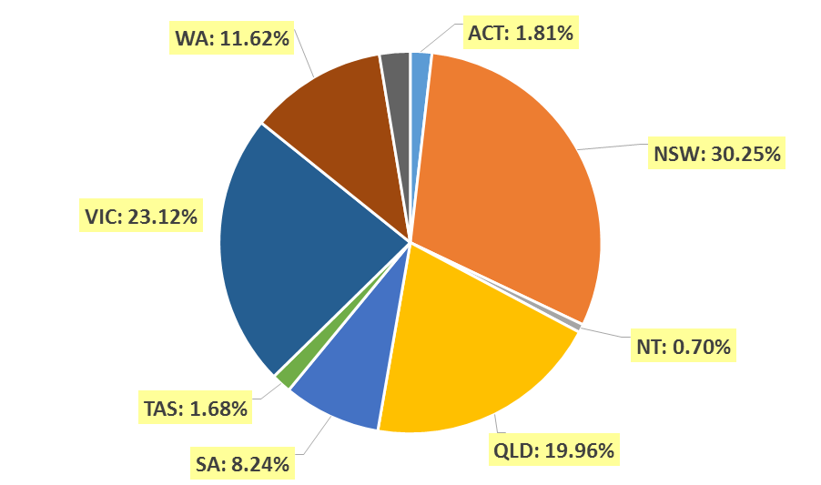

Registration divisions
  - Dental practitioners – division(s) by state or territory
Divisions | ACT | NSW | NT | QLD | SA | TAS | VIC | WA | No PPP | Total
Dental Hygienist | 43 | 420 | 11 | 148 | 282 | 19 | 236 | 266 | 28 | 1,453
Dental Hygienist and Dental Prosthetist |  | 2 |  | 1 |  |  |  |  |  | 3
Dental Hygienist and Dental Prosthetist and Dental Therapist |  | 1 |  |  |  |  | 1 |  |  | 2
Dental Hygienist and Dental Therapist | 8 | 64 | 6 | 135 | 62 | 2 | 129 | 57 | 4 | 467
Dental Hygienist and Dental Therapist and Dentist |  |  |  | 1 |  |  |  |  |  | 1
Dental Hygienist and Dental Therapist and Oral Health Therapist |  | 5 |  | 3 | 5 |  |  |  |  | 13
Dental Hygienist and Dentist |  | 2 |  | 1 |  |  | 1 |  |  | 4
Dental Hygienist and Oral Health Therapist |  | 9 |  | 2 | 1 |  |  | 5 |  | 17
Dental Prosthetist | 14 | 404 | 5 | 269 | 69 | 47 | 354 | 88 | 3 | 1,253
Dental Prosthetist and Dental Therapist |  |  |  |  |  |  | 1 |  |  | 1
Dental Prosthetist and Dentist |  |  |  |  |  |  | 3 |  |  | 3
Dental Prosthetist and Oral Health Therapist |  |  | 1 |  |  |  |  |  |  | 1
Dental Therapist | 15 | 190 | 16 | 169 | 77 | 47 | 139 | 275 | 6 | 934
Dental Therapist and Dentist |  |  |  |  |  |  | 1 |  |  | 1
Dental Therapist and Oral Health Therapist |  |  |  |  |  |  |  | 5 |  | 5
Dentist | 313 | 5,408 | 108 | 3,469 | 1,199 | 254 | 4,045 | 1,815 | 548 | 17,159
Dentist and Oral Health Therapist |  | 2 |  | 1 |  | 1 | 1 |  |  | 5
Oral Health Therapist | 24 | 447 | 15 | 389 | 199 | 17 | 404 | 160 | 10 | 1,665
Total | 417 | 6,954 | 162 | 4,588 | 1,894 | 387 | 5,315 | 2,671 | 599 | 22,987

Registration type and divisions
  - Dental practitioners – registration type and division by state or territory
Registration type | Divisions | ACT | NSW | NT | QLD | SA | TAS | VIC | WA | No PPP | Total
General | Dental Hygienist | 42 | 409 | 11 | 144 | 277 | 19 | 232 | 255 | 19 | 1,408
General | Dental Hygienist and Dental Prosthetist |  | 2 |  | 1 |  |  |  |  |  | 3
General | Dental Hygienist and Dental Prosthetist and Dental Therapist |  | 1 |  |  |  |  | 1 |  |  | 2
General | Dental Hygienist and Dental Therapist | 8 | 60 | 5 | 134 | 62 | 2 | 126 | 56 | 4 | 457
General | Dental Hygienist and Dental Therapist and Dentist |  |  |  | 1 |  |  |  |  |  | 1
General | Dental Hygienist and Dental Therapist and Oral Health Therapist |  | 5 |  | 3 | 5 |  |  |  |  | 13
General | Dental Hygienist and Dentist |  | 2 |  |  |  |  | 1 |  |  | 3
General | Dental Hygienist and Oral Health Therapist |  | 9 |  | 1 | 1 |  |  | 5 |  | 16
General | Dental Prosthetist | 13 | 392 | 5 | 266 | 68 | 46 | 344 | 85 | 1 | 1,220
General | Dental Prosthetist and Dental Therapist |  |  |  |  |  |  | 1 |  |  | 1
General | Dental Prosthetist and Dentist |  |  |  |  |  |  | 3 |  |  | 3
General | Dental Prosthetist and Oral Health Therapist |  |  | 1 |  |  |  |  |  |  | 1
General | Dental Therapist | 15 | 177 | 16 | 165 | 76 | 46 | 130 | 265 | 4 | 894
General | Dental Therapist and Dentist |  |  |  |  |  |  | 1 |  |  | 1
General | Dental Therapist and Oral Health Therapist |  |  |  |  |  |  |  | 5 |  | 5
General | Dentist | 267 | 4,787 | 102 | 3,082 | 1,015 | 229 | 3,498 | 1,586 | 355 | 14,921
General | Dentist and Oral Health Therapist |  | 2 |  | 1 |  | 1 | 1 |  |  | 5
General | Oral Health Therapist | 23 | 442 | 15 | 386 | 196 | 17 | 398 | 159 | 7 | 1,643
Subtotal - General |  | 368 | 6,288 | 155 | 4,184 | 1,700 | 360 | 4,736 | 2,416 | 390 | 20,597
Continued on next page.
Registration Type | Divisions | ACT |  | NSW | NT | QLD | SA | TAS | VIC | WA | No PPP | Total
General and Limited | Dental Hygienist and Dentist
General and Non-practising | Dental Hygienist and Dentist |  |  |  |  | 1 |  |  |  |  |  | 1
General and Non-practising | Dental Hygienist and Oral Health Therapist |  |  |  |  | 1 |  |  |  |  |  | 1
Subtotal – General and non-practicing |  |  |  |  |  | 2 |  |  |  |  |  | 2
General and Specialist | Dentist | 40 |  | 499 | 4 | 322 | 145 | 25 | 426 | 185 | 44 | 1,690
Limited | Dental Hygienist |  |  | 1 |  |  |  |  |  |  |  | 1
Limited | Dentist |  |  | 13 |  | 18 | 10 |  | 8 | 5 |  | 54
Limited | Oral Health Therapist |  |  |  |  |  |  |  | 1 |  |  | 1
Subtotal - Limited |  |  |  | 14 |  | 18 | 10 |  | 9 | 5 |  | 56
Non-practising | Dental Hygienist | 1 |  | 10 |  | 4 | 5 |  | 4 | 11 | 9 | 44
Non-practising | Dental Hygienist and Dental Therapist |  |  | 4 | 1 | 1 |  |  | 3 | 1 |  | 10
Non-practising | Dental Prosthetist | 1 |  | 12 |  | 3 | 1 | 1 | 10 | 3 | 2 | 33
Non-practising | Dental Therapist |  |  | 13 |  | 4 | 1 | 1 | 9 | 10 | 2 | 40
Non-practising | Dentist | 5 |  | 103 | 2 | 43 | 25 |  | 102 | 32 | 140 | 452
Non-practising | Oral Health Therapist | 1 |  | 5 |  | 3 | 3 |  | 5 | 1 | 3 | 21
Subtotal - Non-practising |  |  | 8 | 147 | 3 | 58 | 35 | 2 | 133 | 58 | 156 | 600
Specialist | Dentist |  | 1 | 6 |  | 4 | 4 |  | 11 | 7 | 9 | 42
Total |  | 417 |  | 6,954 | 162 | 4,588 | 1,894 | 387 | 5,315 | 2,671 | 599 | 22,987

Dental specialties
  - Dental practitioners – dental speciality by state or territory
Specialty | ACT | NSW | NT | QLD | SA | TAS | VIC | WA | No PPP | Total
Dento-maxillofacial radiology |  |  |  | 7 |  |  | 1 | 3 |  | 11
Endodontics | 8 | 49 | 1 | 31 | 15 | 3 | 43 | 15 | 7 | 172
Forensic odontology | 2 | 5 | 1 | 2 | 2 | 2 | 4 | 6 |  | 24
Oral and maxillofacial surgery | 3 | 60 | 1 | 44 | 17 | 5 | 58 | 22 | 8 | 218
Oral medicine |  | 9 |  | 5 |  |  | 10 | 9 | 2 | 35
Oral pathology |  | 8 |  | 4 | 3 |  | 3 | 4 | 1 | 23
Oral surgery |  | 35 |  | 4 |  |  | 7 | 2 | 1 | 49
Orthodontics | 13 | 185 | 2 | 126 | 54 | 10 | 146 | 63 | 16 | 615
Paediatric dentistry | 2 | 42 |  | 25 | 14 | 1 | 41 | 18 | 4 | 147
Periodontics | 8 | 61 |  | 40 | 16 | 4 | 60 | 33 | 7 | 229
Prosthodontics | 5 | 73 |  | 43 | 24 |  | 55 | 19 | 6 | 225
Public health dentistry (Community dentistry) |  | 3 |  | 1 | 2 |  | 8 | 1 | 1 | 16
Special needs dentistry |  | 2 |  | 4 | 2 |  | 8 | 1 | 1 | 18
Total | 41 | 532 | 5 | 336 | 149 | 25 | 444 | 196 | 54 | 1,782

Endorsements
  - Dental practitioners – endorsements by state or territory
Endorsement | ACT | NSW | NT | QLD | SA | TAS | VIC | WA | No PPP | Total
Area of Practice – conscious sedation | 4 | 49 | 1 | 21 | 2 | 2 | 7 | 11 | 1 | 98

Age group
  - Dental practitioners – by age group

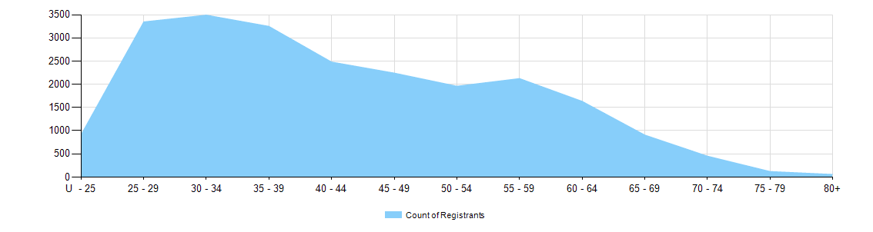

  - Dental practitioners – registration type by age group
Age group | General | General and Specialist | Specialist | Limited |  |  | General and non-practising | Non-practising | Total
 |  |  |  | Postgraduate training or supervised practice | Public interest | Teaching or research | General and non-practising | Non-practising | Total
U - 25 | 915 |  |  |  |  |  |  | 1 | 916
25 - 29 | 3,278 | 18 | 1 | 5 |  |  |  | 44 | 3,346
30 - 34 | 3,281 | 115 | 3 | 6 |  | 4 | 1 | 82 | 3,492
35 - 39 | 2,878 | 281 | 15 | 5 |  | 9 |  | 62 | 3,250
40 - 44 | 2,185 | 228 | 10 |  |  | 8 |  | 50 | 2,481
45 - 49 | 1,987 | 199 | 5 | 1 |  | 7 | 1 | 43 | 2,243
50 - 54 | 1,701 | 191 | 5 |  |  | 4 |  | 60 | 1,961
55 - 59 | 1,834 | 221 |  |  |  | 4 |  | 66 | 2,125
60 - 64 | 1,362 | 202 |  |  |  | 2 |  | 68 | 1,634
65 - 69 | 723 | 131 | 2 |  |  | 1 |  | 51 | 908
70 - 74 | 343 | 64 |  |  |  |  |  | 45 | 452
75 - 79 | 82 | 26 | 1 |  |  |  |  | 12 | 121
80+ | 28 | 14 |  |  |  |  |  | 16 | 58
Total | 20,597 | 1,690 | 42 | 17 |  | 39 | 2 | 600 | 22,987
Gender
  - Dental practitioners – registration type by gender
Gender | Registration type | ACT | NSW | NT | QLD | SA | TAS | VIC | WA | No PPP | Total
Female | General | 235 | 3,094 | 85 | 2,158 | 1,019 | 175 | 2,545 | 1,445 | 180 | 10,936
Female | General and Specialist | 7 | 127 | 1 | 75 | 39 | 6 | 135 | 55 | 13 | 458
Female | Specialist | 1 | 3 |  |  | 1 |  | 7 | 3 | 1 | 16
Female | Limited | 0 | 8 | 0 | 6 | 6 | 0 | 3 | 3 | 0 | 26
Female | Non-practising | 5 | 74 | 1 | 30 | 17 | 2 | 66 | 34 | 72 | 301
Female | General and Non-practising |  |  |  | 2 |  |  |  |  |  | 2
Total female |  | 248 | 3,306 | 87 | 2,271 | 1,082 | 183 | 2,756 | 1,540 | 266 | 11,739
Male | General | 133 | 3,194 | 70 | 2,026 | 681 | 185 | 2,191 | 971 | 210 | 9,661
Male | General and Specialist | 33 | 372 | 3 | 247 | 106 | 19 | 291 | 130 | 31 | 1,232
Male | Specialist |  | 3 |  | 4 | 3 |  | 4 | 4 | 8 | 26
Male | Limited | 0 | 6 | 0 | 12 | 4 | 0 | 6 | 2 | 0 | 30
Male | Non-practising | 3 | 73 | 2 | 28 | 18 |  | 67 | 24 | 84 | 299
Total male |  | 169 | 3,648 | 75 | 2,317 | 812 | 204 | 2,559 | 1,131 | 333 | 11,248
Total |  | 417 | 6,954 | 162 | 4,588 | 1,894 | 387 | 5,315 | 2,671 | 599 | 22,987

  - Dental practitioners – percentage by gender
Gender | ACT | NSW | NT | QLD | SA | TAS | VIC | WA | No PPP | Total
Female | 59.5% | 47.5% | 53.7% | 49.5% | 57.1% | 47.3% | 51.9% | 57.7% | 44.4% | 51.1%
Male | 40.5% | 52.5% | 46.3% | 50.5% | 42.9% | 52.7% | 48.1% | 42.3% | 55.6% | 48.9%

