

Dental Board of Australia

Registrant Data

Reporting period: 1 January 2017 – 31 March 2017

Table of contents

1. Registration type 4
2. Registration divisions 5
3. Registration type and divisions 6
5. Dental specialties 8
6. Endorsements 8
7. Age group 9
8. Gender 10

Introduction
The functions of the Dental Board of Australia (the Board) include:
- registering dentists, students, dental specialists, dental therapists, dental hygienists, oral health therapists and dental prosthetists
- developing standards, codes and guidelines for the dental profession
- handling notifications, complaints, investigations and disciplinary hearings
- overseeing the assessment of overseas trained practitioners who wish to practise in Australia, and
- approving accreditation standards and accredited courses of study.
The Board’s functions are supported by the Australian Health Practitioner Regulation Agency (AHPRA). For information about legislation governing our operations see AHPRA's Legislation & Publications at www.ahpra.gov.au/Publications
The Board has analysed its registration data and produced a number of statistical breakdowns about registrants to share with the profession and community. The Board shares these breakdowns regularly.
For more information on dental registration, please see the Board’s website: http://www.dentalboard.gov.au/Registration.aspx

- Registration type
  - Dental practitioners - registration type by state or territory
Registration Type | Registration Sub-type | ACT | NSW | NT | QLD | SA | TAS | VIC | WA | No PPP | Total
General |  | 363 | 6,114 | 144 | 4,071 | 1,645 | 340 | 4,561 | 2,360 | 397 | 19,995
General and Specialist |  | 41 | 475 | 4 | 319 | 141 | 27 | 412 | 183 | 42 | 1,644
General and Non-practising |  |  |  |  | 1 |  |  |  |  |  | 1
Specialist |  | 2 | 5 |  | 4 | 4 |  | 10 | 5 | 6 | 36
Limited | Postgraduate training or supervised practice | 1 | 5 |  | 1 | 8 |  | 8 | 2 |  | 25
Limited | Public interest
Limited | Teaching or research |  | 12 |  | 17 | 6 |  | 5 | 1 |  | 41
Non-practising |  | 6 | 145 | 5 | 61 | 34 | 5 | 117 | 51 | 147 | 571
Total |  | 413 | 6,756 | 153 | 4,474 | 1,838 | 372 | 5,113 | 2,602 | 592 | 22,313

  - Dental practitioners - percentage by principal place of practice
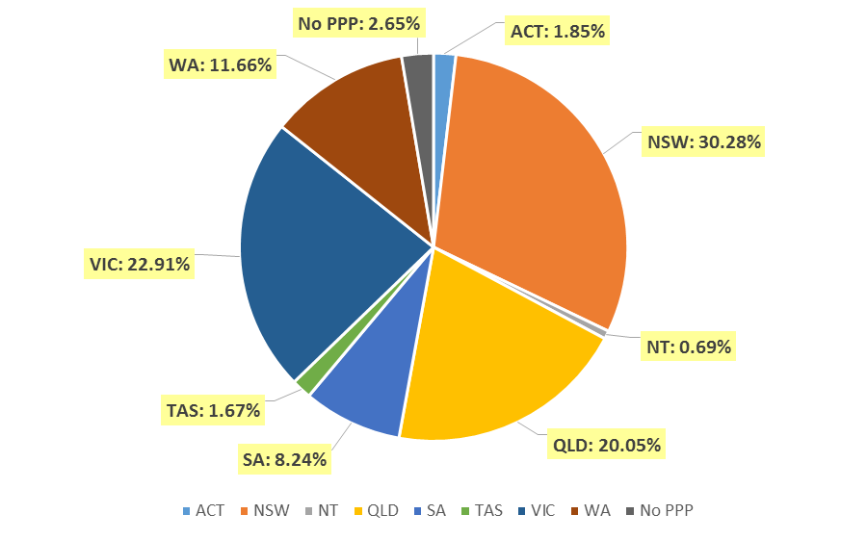

- Registration divisions
  - Dental practitioners - division(s) by state or territory
Divisions | ACT | NSW | NT | QLD | SA | TAS | VIC | WA | No PPP | Total
Dental Hygienist | 43 | 443 | 11 | 143 | 266 | 18 | 218 | 267 | 28 | 1,437
Dental Hygienist and Dental Prosthetist |  | 2 |  | 1 |  |  |  |  |  | 3
Dental Hygienist and Dental Prosthetist and Dental Therapist |  | 1 |  |  |  |  | 1 |  |  | 2
Dental Hygienist and Dental Therapist | 9 | 67 | 7 | 140 | 62 | 2 | 120 | 57 | 2 | 466
Dental Hygienist and Dental Therapist and Dentist |  |  |  | 2 |  |  |  |  |  | 2
Dental Hygienist and Dental Therapist and Oral Health Therapist |  |  |  | 3 |  |  |  |  |  | 3
Dental Hygienist and Dentist |  | 2 |  | 1 |  |  | 1 |  |  | 4
Dental Hygienist and Oral Health Therapist |  | 2 |  |  | 1 |  |  | 5 |  | 8
Dental Prosthetist | 14 | 409 | 5 | 268 | 69 | 49 | 354 | 89 | 5 | 1,262
Dental Prosthetist and Dental Therapist |  |  |  |  |  |  | 1 |  |  | 1
Dental Prosthetist and Dentist |  |  |  |  |  |  | 2 |  |  | 2
Dental Therapist | 18 | 198 | 16 | 173 | 81 | 47 | 148 | 277 | 5 | 963
Dental Therapist and Dentist |  |  |  |  |  |  | 1 |  |  | 1
Dental Therapist and Oral Health Therapist |  |  |  |  |  |  |  | 6 |  | 6
Dentist | 310 | 5,255 | 101 | 3,356 | 1,177 | 245 | 3,921 | 1,772 | 547 | 16,684
Dentist and Oral Health Therapist |  | 1 |  | 1 |  |  |  |  |  | 2
Oral Health Therapist | 19 | 376 | 13 | 386 | 182 | 11 | 346 | 129 | 5 | 1,467
Total | 413 | 6,756 | 153 | 4,474 | 1,838 | 372 | 5,113 | 2,602 | 592 | 22,313

- Registration type and divisions
  - Dental practitioners – registration type and division by state or territory
Registration Type | Divisions | ACT | NSW | NT | QLD | SA | TAS | VIC | WA | No PPP | Total
General | Dental Hygienist | 43 | 434 | 10 | 141 | 262 | 18 | 215 | 256 | 19 | 1,398
General | Dental Hygienist and Dental Prosthetist |  | 2 |  | 1 |  |  |  |  |  | 3
General | Dental Hygienist and Dental Prosthetist and Dental Therapist |  | 1 |  |  |  |  | 1 |  |  | 2
General | Dental Hygienist and Dental Therapist | 9 | 64 | 6 | 139 | 62 | 2 | 117 | 56 | 2 | 457
General | Dental Hygienist and Dental Therapist and Dentist |  |  |  | 2 |  |  |  |  |  | 2
General | Dental Hygienist and Dental Therapist and Oral Health Therapist |  |  |  | 3 |  |  |  |  |  | 3
General | Dental Hygienist and Dentist |  | 2 |  |  |  |  | 1 |  |  | 3
General | Dental Hygienist and Oral Health Therapist |  | 2 |  |  | 1 |  |  | 5 |  | 8
General | Dental Prosthetist | 12 | 396 | 5 | 264 | 68 | 48 | 345 | 86 | 3 | 1,227
General | Dental Prosthetist and Dental Therapist |  |  |  |  |  |  | 1 |  |  | 1
General | Dental Prosthetist and Dentist |  |  |  |  |  |  | 2 |  |  | 2
General | Dental Therapist | 18 | 186 | 16 | 170 | 79 | 46 | 138 | 268 | 4 | 925
General | Dental Therapist and Dentist |  |  |  |  |  |  | 1 |  |  | 1
General | Dental Therapist and Oral Health Therapist |  |  |  |  |  |  |  | 6 |  | 6
General | Dentist | 263 | 4,656 | 94 | 2,969 | 995 | 215 | 3,398 | 1,556 | 366 | 14,512
General | Dentist and Oral Health Therapist |  | 1 |  | 1 |  |  |  |  |  | 2
General | Oral Health Therapist | 18 | 370 | 13 | 381 | 178 | 11 | 342 | 127 | 3 | 1,443
Sub Total |  | 363 | 6,114 | 144 | 4,071 | 1,645 | 340 | 4,561 | 2,360 | 397 | 19,995
General and Specialist | Dentist | 41 | 475 | 4 | 319 | 141 | 27 | 412 | 183 | 42 | 1,644
Specialist | Dentist | 2 | 5 |  | 4 | 4 |  | 10 | 5 | 6 | 36
Limited | Dental Hygienist |  | 1 |  |  |  |  |  |  |  | 1
Limited | Dentist | 1 | 16 |  | 18 | 14 |  | 12 | 3 |  | 64
Limited | Oral Health Therapist |  |  |  |  |  |  | 1 |  |  | 1
Sub Total |  | 1 | 17 |  | 18 | 14 |  | 13 | 3 |  | 66
Continued on next page

Registration Type | Divisions | ACT | NSW | NT | QLD | SA | TAS | VIC | WA | No PPP | Total
General and Non-practising | Dental Hygienist and Dentist |  |  |  | 1 |  |  |  |  |  | 1
Non-practising | Dental Hygienist |  | 8 | 1 | 2 | 4 |  | 3 | 11 | 9 | 38
Non-practising | Dental Hygienist and Dental Therapist |  | 3 | 1 | 1 |  |  | 3 | 1 |  | 9
Non-practising | Dental Prosthetist | 2 | 13 |  | 4 | 1 | 1 | 9 | 3 | 2 | 35
Non-practising | Dental Therapist |  | 12 |  | 3 | 2 | 1 | 10 | 9 | 1 | 38
Non-practising | Dentist | 3 | 103 | 3 | 46 | 23 | 3 | 89 | 25 | 133 | 428
Non-practising | Oral Health Therapist | 1 | 6 |  | 5 | 4 |  | 3 | 2 | 2 | 23
Sub Total |  | 6 | 145 | 5 | 61 | 34 | 5 | 117 | 51 | 147 | 571
Total |  | 413 | 6,756 | 153 | 4,474 | 1,838 | 372 | 5,113 | 2,602 | 592 | 22,313

- Dental specialties
  - Dental practitioners – dental speciality by state or territory
Specialty | ACT | NSW | NT | QLD | SA | TAS | VIC | WA | No PPP | Total
Dento-maxillofacial radiology |  |  |  | 6 |  |  | 1 | 3 |  | 10
Endodontics | 8 | 49 | 1 | 29 | 15 | 3 | 42 | 15 | 5 | 167
Forensic odontology | 2 | 5 | 1 | 2 | 2 | 2 | 5 | 6 |  | 25
Oral and maxillofacial surgery | 3 | 55 | 1 | 46 | 16 | 5 | 54 | 23 | 6 | 209
Oral medicine |  | 7 |  | 5 |  |  | 11 | 8 | 3 | 34
Oral pathology |  | 6 |  | 4 | 3 |  | 3 | 4 | 2 | 22
Oral surgery |  | 37 |  | 4 |  |  | 7 | 2 | 1 | 51
Orthodontics | 13 | 181 | 2 | 126 | 54 | 12 | 139 | 63 | 19 | 609
Paediatric dentistry | 2 | 37 |  | 24 | 13 | 1 | 38 | 14 | 3 | 132
Periodontics | 10 | 61 |  | 40 | 16 | 4 | 60 | 32 | 4 | 227
Prosthodontics | 5 | 63 |  | 42 | 22 |  | 54 | 21 | 5 | 212
Public health dentistry (Community dentistry) |  | 3 |  | 1 | 2 |  | 8 | 1 | 1 | 16
Special needs dentistry |  | 2 |  | 4 | 2 |  | 7 |  | 1 | 16
Total | 43 | 506 | 5 | 333 | 145 | 27 | 429 | 192 | 50 | 1,730

- Endorsements
  - Dental practitioners – endorsements by state or territory
Endorsement | ACT | NSW | NT | QLD | SA | TAS | VIC | WA | No PPP | Total
Area of Practice – conscious sedation | 4 | 48 | 2 | 21 | 2 | 2 | 5 | 10 |  | 94

- Age group
  - Dental practitioners – by age group
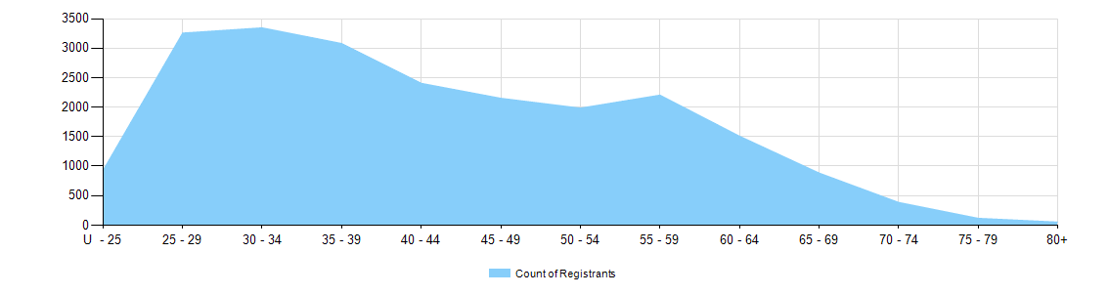

  - Dental practitioners – registration type by age group
Age Group | General | General and Specialist | Specialist | Limited |  |  | General and Non-practising | Non-practising | Total
 |  |  |  | Postgraduate training or supervised practice | Public interest | Teaching or research | General and Non-practising | Non-practising | Total
U - 25 | 928 |  |  |  |  |  |  | 2 | 930
25 - 29 | 3,186 | 13 | 1 | 10 |  | 1 |  | 46 | 3,257
30 - 34 | 3,134 | 111 | 4 | 10 |  | 4 | 1 | 82 | 3,346
35 - 39 | 2,715 | 281 | 13 | 3 |  | 10 |  | 58 | 3,080
40 - 44 | 2,125 | 219 | 8 | 2 |  | 8 |  | 44 | 2,406
45 - 49 | 1,904 | 184 | 6 |  |  | 7 |  | 51 | 2,152
50 - 54 | 1,741 | 193 | 2 |  |  | 5 |  | 44 | 1,985
55 - 59 | 1,904 | 234 |  |  |  | 3 |  | 65 | 2,206
60 - 64 | 1,253 | 190 |  |  |  | 1 |  | 66 | 1,510
65 - 69 | 714 | 123 | 1 |  |  | 1 |  | 46 | 885
70 - 74 | 286 | 61 |  |  |  |  |  | 39 | 386
75 - 79 | 78 | 25 | 1 |  |  | 1 |  | 12 | 117
80+ | 27 | 10 |  |  |  |  |  | 16 | 53
Total | 19,995 | 1,644 | 36 | 25 |  | 41 | 1 | 571 | 22,313

- Gender
  - Dental practitioners – registration type by gender
Gender | Registration Type | ACT | NSW | NT | QLD | SA | TAS | VIC | WA | No PPP | Total
Female | General | 226 | 2,930 | 80 | 2,081 | 963 | 160 | 2,404 | 1,410 | 181 | 10,435
Female | General and Specialist | 7 | 114 | 1 | 73 | 38 | 7 | 130 | 50 | 11 | 431
Female | Specialist | 1 | 2 |  |  | 1 |  | 6 | 2 |  | 12
Female | Limited |  | 10 |  | 7 | 8 |  | 5 | 2 |  | 32
Female | Non-practising | 4 | 72 | 3 | 33 | 18 | 2 | 58 | 32 | 67 | 289
Female | General and Non-practising |  |  |  | 1 |  |  |  |  |  | 1
Total Female |  | 238 | 3,128 | 84 | 2,195 | 1,028 | 169 | 2,603 | 1,496 | 259 | 11,200
Male | General | 137 | 3,184 | 64 | 1,990 | 682 | 180 | 2,157 | 950 | 216 | 9,560
Male | General and Specialist | 34 | 361 | 3 | 246 | 103 | 20 | 282 | 133 | 31 | 1,213
Male | Specialist | 1 | 3 |  | 4 | 3 |  | 4 | 3 | 6 | 24
Male | Limited | 1 | 7 |  | 11 | 6 |  | 8 | 1 |  | 34
Male | Non-practising | 2 | 73 | 2 | 28 | 16 | 3 | 59 | 19 | 80 | 282
Total Male |  | 175 | 3,628 | 69 | 2,279 | 810 | 203 | 2,510 | 1,106 | 333 | 11,113
Total |  | 413 | 6,756 | 153 | 4,474 | 1,838 | 372 | 5,113 | 2,602 | 592 | 22,313

  - Dental practitioners – percentage by gender
Gender | ACT | NSW | NT | QLD | SA | TAS | VIC | WA | No PPP | Total
Female | 57.6% | 46.3% | 54.9% | 49.1% | 55.9% | 45.4% | 50.9% | 57.5% | 43.8% | 50.2%
Male | 42.4% | 53.7% | 45.1% | 50.9% | 44.1% | 54.6% | 49.1% | 42.5% | 56.3% | 49.8%

