Dental Practitioner Registrant Data: December 2012

Published January 2013
Introduction
The functions of the Dental Board of Australia include:
- registering dentists, students, dental specialists, dental therapists, dental hygienists, oral health therapists and dental prosthetists
- developing standards, codes and guidelines for the dental profession
- handling notifications, complaints, investigations and disciplinary hearings
- assessing overseas trained practitioners who wish to practise in Australia
- approving accreditation standards and accredited courses of study.

The Board’s functions are supported by Australian Health Practitioner Regulation Agency (AHPRA). For information about legislation governing our operations see AHPRA's Legislation & Publications at www.ahpra.gov.au/Legislation-and-Publications.aspx

The Board has analysed its registration data and produced a number of statistical breakdowns about registrants to share with the profession and community. The Board shares these breakdowns regularly.

For more information on dental registration, please see the Board’s website:
http://www.dentalboard.gov.au/Registration.aspx

Index of Tables
Dental practitioners: State and Territory by Registration Type 2
Dental practitioners: Age by Registration Type 3
Dental practitioners: Gender by State and Territory by Registration Type 4
Dental practitioners: Endorsement Type by State and Territory 4
Dental practitioners: Registration Numbers by Division by State and Territory 4

Dental Practitioners: State and Territory by Registration Type
State | General | General and Specialist | Limited |  |  | Non-practising | Specialist | Total | % By State
 |  |  | Postgraduate training or supervised practice | Public interest | Teaching or research
ACT | 318 | 40 |  |  |  | 3 |  | 361 | 1.83%
NSW | 5,455 | 448 | 93 | 1 | 8 | 98 | 8 | 6,111 | 30.93%
NT | 127 | 7 |  |  |  | 1 | 1 | 136 | 0.69%
QLD | 3,447 | 290 | 46 |  | 19 | 42 | 1 | 3,845 | 19.46%
SA | 1,478 | 134 | 29 |  | 9 | 13 | 3 | 1,666 | 8.43%
TAS | 305 | 22 | 6 |  |  | 4 |  | 337 | 1.71%
VIC | 3,918 | 370 | 103 |  | 6 | 104 | 8 | 4,509 | 22.82%
WA | 2,078 | 146 | 35 |  | 1 | 60 | 2 | 2,322 | 11.75%
Not Stated | 372 | 39 | 7 |  |  | 50 | 4 | 472 | 2.39%
Total | 17,498 | 1,496 | 319 | 1 | 43 | 375 | 27 | 19,759

% By State and Territory
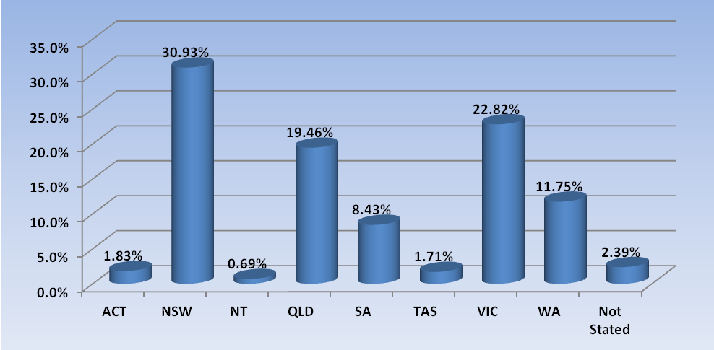

Dental Practitioners: Age by Registration Type
Age Group | General | General and Specialist | Limited |  |  | Non-practising | Specialist | Total | % By Age Group
 |  |  | Postgraduate training or supervised practice | Public interest | Teaching or research
21 - 25 | 933 |  |  |  |  | 7 |  | 940 | 4.76%
26 - 30 | 2,489 | 7 | 99 |  | 1 | 26 | 1 | 2,623 | 13.27%
31 - 35 | 2,561 | 155 | 130 |  | 11 | 51 | 8 | 2,916 | 14.76%
36 - 40 | 2,047 | 168 | 56 |  | 8 | 45 | 7 | 2,331 | 11.8%
41 - 45 | 1,940 | 195 | 23 |  | 5 | 30 | 4 | 2,197 | 11.12%
46 - 50 | 1,776 | 190 | 6 |  | 7 | 36 | 3 | 2,018 | 10.21%
51 - 55 | 2,020 | 222 | 1 | 1 | 4 | 36 | 1 | 2,285 | 11.56%
56 - 60 | 1,664 | 222 | 4 |  | 3 | 37 |  | 1,930 | 9.77%
61 - 65 | 1,063 | 156 |  |  | 3 | 38 | 1 | 1,261 | 6.38%
66 - 70 | 620 | 115 |  |  |  | 27 |  | 762 | 3.86%
71 - 75 | 226 | 35 |  |  | 1 | 20 | 1 | 283 | 1.43%
76 - 80 | 93 | 25 |  |  |  | 7 | 1 | 126 | 0.64%
81 - 85 | 36 | 4 |  |  |  | 10 |  | 50 | 0.25%
86 + | 14 | 2 |  |  |  | 5 |  | 21 | 0.11%
Not Stated | 16 |  |  |  |  |  |  | 16 | 0.08%
Total | 17,498 | 1,496 | 319 | 1 | 43 | 375 | 27 | 19,759

% by Age Group
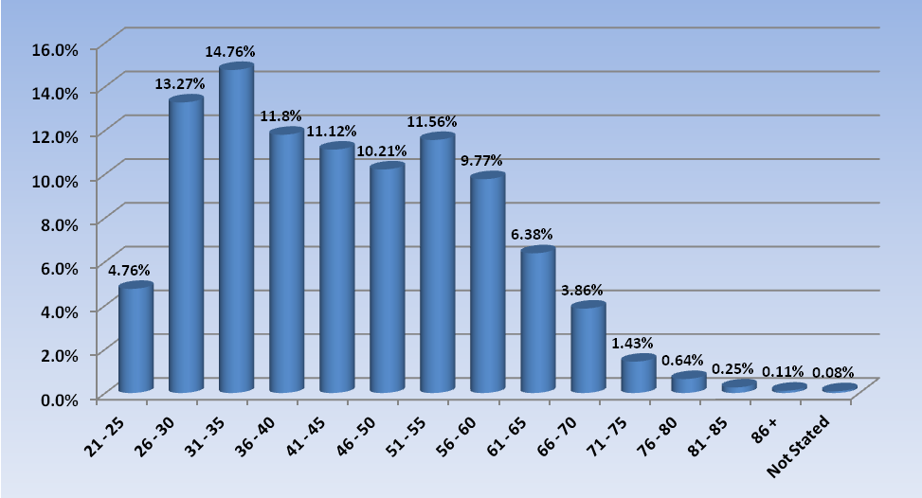

Dental Practitioners: Gender by State/Territory by Registration Type
Sex | State | General | General and Specialist | Limited |  |  | Non-practising | Specialist | Total Count | % By Sex By State
 |  |  |  | Postgraduate training or supervised practice | Public interest | Teaching or research
Female | ACT | 179 | 4 |  |  |  | 2 |  | 185 | 0.94%
Female | NSW | 2,370 | 94 | 47 |  | 5 | 50 | 4 | 2,570 | 13.01%
Female | NT | 69 | 1 |  |  |  |  |  | 70 | 0.35%
Female | QLD | 1,635 | 60 | 24 |  | 6 | 20 |  | 1,745 | 8.83%
Female | SA | 799 | 33 | 14 |  | 6 | 8 | 1 | 861 | 4.36%
Female | TAS | 58 | 1 | 1 |  |  | 3 |  | 63 | 0.32%
Female | VIC | 1,887 | 102 | 69 |  | 3 | 54 | 5 | 2,120 | 10.73%
Female | WA | 1,165 | 31 | 27 |  | 1 | 42 | 1 | 1,267 | 6.41%
Female | Not Stated | 141 | 9 | 4 |  |  | 25 |  | 179 | 0.91%
Female | Sub total | 8,303 | 335 | 186 |  | 21 | 204 | 11 | 9,060 | 45.85%
Male | ACT | 139 | 36 |  |  |  | 1 |  | 176 | 0.89%
Male | NSW | 3,068 | 353 | 46 | 1 | 3 | 48 | 4 | 3,523 | 17.83%
Male | NT | 58 | 6 |  |  |  | 1 | 1 | 66 | 0.33%
Male | QLD | 1,808 | 230 | 21 |  | 13 | 22 | 1 | 2,095 | 10.6%
Male | SA | 651 | 101 | 15 |  | 3 | 5 | 2 | 777 | 3.93%
Male | TAS | 150 | 19 | 5 |  |  | 1 |  | 175 | 0.89%
Male | VIC | 2,025 | 268 | 34 |  | 3 | 50 | 3 | 2,383 | 12.06%
Male | WA | 817 | 109 | 8 |  |  | 17 | 1 | 952 | 4.82%
Male | Not Stated | 225 | 30 | 3 |  |  | 24 | 4 | 286 | 1.45%
Male | Sub total | 8,941 | 1,152 | 132 | 1 | 22 | 169 | 16 | 10,433 | 52.8%
Not Stated | NSW | 17 | 1 |  |  |  |  |  | 18 | 0.09%
Not Stated | QLD | 4 |  | 1 |  |  |  |  | 5 | 0.03%
Not Stated | SA | 28 |  |  |  |  |  |  | 28 | 0.14%
Not Stated | TAS | 97 | 2 |  |  |  |  |  | 99 | 0.5%
Not Stated | VIC | 6 |  |  |  |  |  |  | 6 | 0.03%
Not Stated | WA | 96 | 6 |  |  |  | 1 |  | 103 | 0.52%
Not Stated | Not Stated | 6 |  |  |  |  | 1 |  | 7 | 0.04%
Not Stated | Sub total | 254 | 9 | 1 |  |  | 2 |  | 266 | 1.35%
Total |  | 17,498 | 1,496 | 319 | 1 | 43 | 375 | 27 | 19,759

Dental Practitioners: Endorsement Type by State and Territory
Endorsement | ACT | NSW | NT | QLD | SA | TAS | VIC | WA | No PPP | Grand Total
Area of Practice - Conscious sedation

Dental Practitioners: Registration Numbers by Division by State/Territory

 | ACT | NSW | NT | QLD | SA | TAS | VIC | WA | NoPPP | Total
Dental Hygienist | 46 | 348 | 7 | 123 | 232 | 16 | 177 | 290 | 16 | 1,255
Dental Hygienist and Dental prosthetist |  | 1 |  | 1 |  |  |  |  |  | 2
Dental Hygienist and Dental prosthetist and Dental Therapist |  | 1 |  |  |  |  | 1 |  |  | 2
Dental Hygienist and Dental Therapist | 11 | 60 | 7 | 173 | 70 | 1 | 132 | 54 | 2 | 510
Dental Hygienist and Dental Therapist and Dentist |  |  |  |  | 1 |  |  |  |  | 1
Dental Hygienist and Dentist | 1 | 1 |  |  |  |  |  |  |  | 2
Dental prosthetist | 14 | 424 | 5 | 229 | 54 | 52 | 333 | 90 | 4 | 1,205
Dental Therapist | 18 | 241 | 17 | 212 | 103 | 53 | 175 | 341 | 1 | 1,161
Dental Therapist and Dentist |  | 1 |  |  |  |  |  |  |  | 1
Dentist | 265 | 4,872 | 97 | 2,841 | 1,130 | 210 | 3,596 | 1,560 | 332 | 14,903
Dentist and Oral Health Therapist |  | 1 |  |  |  |  |  |  |  | 1
Oral Health Therapist | 8 | 183 | 4 | 277 | 83 | 5 | 150 | 5 | 1 | 716
Dental Practitioner | 363 | 6,133 | 137 | 3,856 | 1,673 | 337 | 4,564 | 2,340 | 356 | 19,759

