

Dental Board of Australia

Registrant Data

Reporting period: 1 July 2017 – 30 September 2017

Table of contents

1. Registration type 4
2. Registration divisions 5
3. Registration type and divisions 6
5. Dental specialties 8
6. Endorsements 8
7. Age group 9
8. Gender 10

Introduction
The functions of the Dental Board of Australia (the Board) include:
- registering dentists, students, dental specialists, dental therapists, dental hygienists, oral health therapists and dental prosthetists
- developing standards, codes and guidelines for the dental profession
- handling notifications, complaints, investigations and disciplinary hearings
- overseeing the assessment of overseas trained practitioners who wish to practise in Australia, and
- approving accreditation standards and accredited courses of study.
The Board’s functions are supported by the Australian Health Practitioner Regulation Agency (AHPRA). For information about legislation governing our operations see AHPRA's Legislation & Publications at www.ahpra.gov.au/Publications
The Board has analysed its registration data and produced a number of statistical breakdowns about registrants to share with the profession and community. The Board shares these breakdowns regularly.
For more information on dental registration, please see the Board’s website: www.dentalboard.gov.au/Registration.aspx

- Registration type
  - Dental practitioners – registration type by state or territory
Registration Type | Registration Sub-type | ACT | NSW | NT | QLD | SA | TAS | VIC | WA | No PPP | Total
General |  | 360 | 6,140 | 152 | 4,073 | 1,643 | 342 | 4,609 | 2,374 | 420 | 20,113
General and Specialist |  | 41 | 481 | 4 | 320 | 145 | 27 | 415 | 185 | 44 | 1,662
General and Non-practising |  |  |  |  | 1 |  |  |  |  |  | 1
Specialist |  | 1 | 6 |  | 4 | 4 |  | 11 | 5 | 9 | 40
Limited | Postgraduate training or supervised practice |  | 3 |  | 1 | 5 |  | 4 | 2 |  | 15
Limited | Public interest
Limited | Teaching or research |  | 13 |  | 17 | 8 |  | 4 | 1 |  | 43
Non-practising |  | 6 | 144 | 4 | 62 | 36 | 5 | 127 | 51 | 148 | 583
Total |  | 408 | 6,787 | 160 | 4,478 | 1,841 | 374 | 5,170 | 2,618 | 621 | 22,457

  - Dental practitioners – percentage by principal place of practice
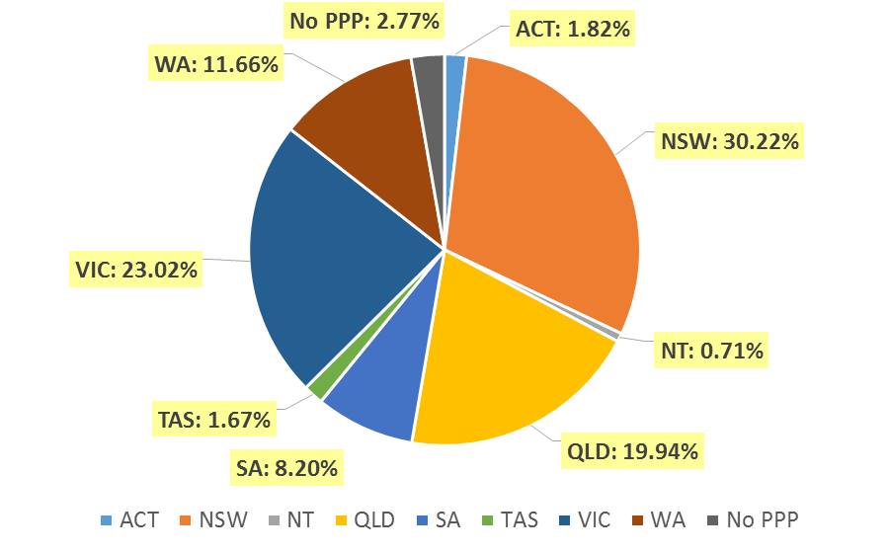

- Registration divisions
  - Dental practitioners – division(s) by state or territory
Divisions | ACT | NSW | NT | QLD | SA | TAS | VIC | WA | No PPP | Total
Dental Hygienist | 42 | 441 | 11 | 144 | 268 | 19 | 219 | 270 | 29 | 1,443
Dental Hygienist and Dental Prosthetist |  | 2 |  | 1 |  |  |  |  |  | 3
Dental Hygienist and Dental Prosthetist and Dental Therapist |  | 1 |  |  |  |  | 1 |  |  | 2
Dental Hygienist and Dental Therapist | 9 | 67 | 7 | 139 | 62 | 2 | 127 | 57 | 5 | 475
Dental Hygienist and Dental Therapist and Dentist |  |  |  | 2 |  |  |  |  |  | 2
Dental Hygienist and Dental Therapist and Oral Health Therapist |  |  |  | 3 |  |  |  |  |  | 3
Dental Hygienist and Dentist |  | 2 |  | 1 |  |  | 1 |  |  | 4
Dental Hygienist and Oral Health Therapist |  | 2 |  |  | 1 |  |  | 5 |  | 8
Dental Prosthetist | 14 | 412 | 6 | 272 | 73 | 49 | 359 | 90 | 4 | 1,279
Dental Prosthetist and Dental Therapist |  |  |  |  |  |  | 1 |  |  | 1
Dental Prosthetist and Dentist |  |  |  |  |  |  | 2 |  |  | 2
Dental Therapist | 18 | 198 | 18 | 173 | 81 | 47 | 148 | 278 | 5 | 966
Dental Therapist and Dentist |  |  |  |  |  |  | 1 |  |  | 1
Dental Therapist and Oral Health Therapist |  |  |  |  |  |  |  | 6 |  | 6
Dentist | 305 | 5,281 | 104 | 3,357 | 1,177 | 246 | 3,946 | 1,781 | 572 | 16,769
Dentist and Oral Health Therapist |  | 1 |  | 1 |  |  |  |  |  | 2
Oral Health Therapist | 20 | 380 | 14 | 385 | 179 | 11 | 365 | 131 | 6 | 1,491
Total | 408 | 6,787 | 160 | 4,478 | 1,841 | 374 | 5,170 | 2,618 | 621 | 22,457

- Registration type and divisions
  - Dental practitioners – registration type and division by state or territory
Registration Type | Divisions | ACT | NSW | NT | QLD | SA | TAS | VIC | WA | No PPP | Total
General | Dental Hygienist | 42 | 431 | 10 | 142 | 263 | 19 | 216 | 259 | 20 | 1,402
General | Dental Hygienist and Dental Prosthetist |  | 2 |  | 1 |  |  |  |  |  | 3
General | Dental Hygienist and Dental Prosthetist and Dental Therapist |  | 1 |  |  |  |  | 1 |  |  | 2
General | Dental Hygienist and Dental Therapist | 9 | 64 | 6 | 138 | 62 | 2 | 124 | 56 | 5 | 466
General | Dental Hygienist and Dental Therapist and Dentist |  |  |  | 2 |  |  |  |  |  | 2
General | Dental Hygienist and Dental Therapist and Oral Health Therapist |  |  |  | 3 |  |  |  |  |  | 3
General | Dental Hygienist and Dentist |  | 2 |  |  |  |  | 1 |  |  | 3
General | Dental Hygienist and Oral Health Therapist |  | 2 |  |  | 1 |  |  | 5 |  | 8
General | Dental Prosthetist | 12 | 398 | 6 | 268 | 72 | 48 | 350 | 87 | 2 | 1,243
General | Dental Prosthetist and Dental Therapist |  |  |  |  |  |  | 1 |  |  | 1
General | Dental Prosthetist and Dentist |  |  |  |  |  |  | 2 |  |  | 2
General | Dental Therapist | 18 | 187 | 18 | 170 | 79 | 46 | 137 | 269 | 4 | 928
General | Dental Therapist and Dentist |  |  |  |  |  |  | 1 |  |  | 1
General | Dental Therapist and Oral Health Therapist |  |  |  |  |  |  |  | 6 |  | 6
General | Dentist | 260 | 4,677 | 98 | 2,968 | 992 | 216 | 3,416 | 1,562 | 385 | 14,574
General | Dentist and Oral Health Therapist |  | 1 |  | 1 |  |  |  |  |  | 2
General | Oral Health Therapist | 19 | 375 | 14 | 380 | 174 | 11 | 360 | 130 | 4 | 1,467
Sub Total |  | 360 | 6,140 | 152 | 4,073 | 1,643 | 342 | 4,609 | 2,374 | 420 | 20,113
General and Specialist | Dentist | 41 | 481 | 4 | 320 | 145 | 27 | 415 | 185 | 44 | 1,662
Specialist | Dentist | 1 | 6 |  | 4 | 4 |  | 11 | 5 | 9 | 40
Limited | Dental Hygienist |  | 1 |  |  |  |  |  |  |  | 1
Limited | Dentist |  | 15 |  | 18 | 13 |  | 7 | 3 |  | 56
Limited | Oral Health Therapist |  |  |  |  |  |  | 1 |  |  | 1
Sub Total |  |  | 16 |  | 18 | 13 |  | 8 | 3 |  | 58
Continued on next page

Registration Type | Divisions | ACT | NSW | NT | QLD | SA | TAS | VIC | WA | No PPP | Total
General and Non-practising | Dental Hygienist and Dentist |  |  |  | 1 |  |  |  |  |  | 1
Non-practising | Dental Hygienist |  | 9 | 1 | 2 | 5 |  | 3 | 11 | 9 | 40
Non-practising | Dental Hygienist and Dental Therapist |  | 3 | 1 | 1 |  |  | 3 | 1 |  | 9
Non-practising | Dental Prosthetist | 2 | 14 |  | 4 | 1 | 1 | 9 | 3 | 2 | 36
Non-practising | Dental Therapist |  | 11 |  | 3 | 2 | 1 | 11 | 9 | 1 | 38
Non-practising | Dentist | 3 | 102 | 2 | 47 | 23 | 3 | 97 | 26 | 134 | 437
Non-practising | Oral Health Therapist | 1 | 5 |  | 5 | 5 |  | 4 | 1 | 2 | 23
Sub Total |  | 6 | 144 | 4 | 62 | 36 | 5 | 127 | 51 | 148 | 583
Total |  | 408 | 6,787 | 160 | 4,478 | 1,841 | 374 | 5,170 | 2,618 | 621 | 22,457

- Dental specialties
  - Dental practitioners – dental speciality by state or territory
Specialty | ACT | NSW | NT | QLD | SA | TAS | VIC | WA | No PPP | Total
Dento-maxillofacial radiology |  |  |  | 6 |  |  | 1 | 3 |  | 10
Endodontics | 8 | 49 | 1 | 30 | 15 | 3 | 42 | 15 | 7 | 170
Forensic odontology | 2 | 5 | 1 | 2 | 2 | 2 | 5 | 6 |  | 25
Oral and maxillofacial surgery | 3 | 55 | 1 | 44 | 16 | 5 | 56 | 23 | 8 | 211
Oral medicine |  | 9 |  | 5 |  |  | 11 | 8 | 2 | 35
Oral pathology |  | 8 |  | 4 | 3 |  | 3 | 4 | 1 | 23
Oral surgery |  | 37 |  | 4 |  |  | 7 | 2 | 1 | 51
Orthodontics | 13 | 181 | 2 | 127 | 54 | 12 | 141 | 64 | 19 | 613
Paediatric dentistry | 2 | 38 |  | 24 | 15 | 1 | 38 | 15 | 3 | 136
Periodontics | 9 | 61 |  | 39 | 16 | 4 | 59 | 32 | 6 | 226
Prosthodontics | 5 | 66 |  | 44 | 24 |  | 54 | 21 | 5 | 219
Public health dentistry (Community dentistry) |  | 3 |  | 1 | 2 |  | 8 | 1 | 1 | 16
Special needs dentistry |  | 2 |  | 4 | 2 |  | 8 |  | 1 | 17
Total | 42 | 514 | 5 | 334 | 149 | 27 | 433 | 194 | 54 | 1,752

- Endorsements
  - Dental practitioners – endorsements by state or territory
Endorsement | ACT | NSW | NT | QLD | SA | TAS | VIC | WA | No PPP | Total
Area of Practice – conscious sedation | 4 | 50 | 2 | 21 | 2 | 2 | 5 | 10 | 1 | 97

- Age group
  - Dental practitioners – by age group
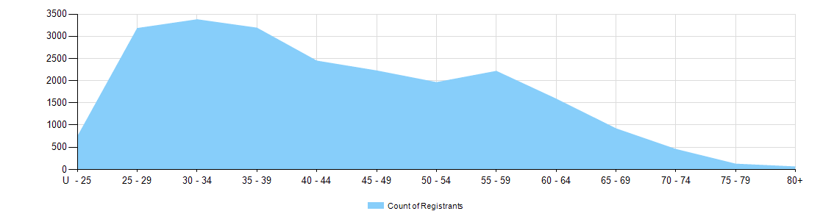

  - Dental practitioners – registration type by age group
Age Group | General | General and Specialist | Specialist | Limited |  |  | General and Non-practising | Non-practising | Total
 |  |  |  | Postgraduate training or supervised practice | Public interest | Teaching or research | General and Non-practising | Non-practising | Total
U - 25 | 737 |  |  |  |  |  |  | 2 | 739
25 - 29 | 3,117 | 11 | 1 | 4 |  |  |  | 45 | 3,178
30 - 34 | 3,171 | 103 | 4 | 9 |  | 6 | 1 | 81 | 3,375
35 - 39 | 2,818 | 286 | 13 | 1 |  | 10 |  | 58 | 3,186
40 - 44 | 2,167 | 212 | 10 | 1 |  | 9 |  | 45 | 2,444
45 - 49 | 1,960 | 202 | 6 |  |  | 6 |  | 48 | 2,222
50 - 54 | 1,710 | 188 | 3 |  |  | 6 |  | 52 | 1,959
55 - 59 | 1,916 | 227 |  |  |  | 3 |  | 67 | 2,213
60 - 64 | 1,323 | 200 |  |  |  | 2 |  | 63 | 1,588
65 - 69 | 742 | 122 | 2 |  |  | 1 |  | 51 | 918
70 - 74 | 341 | 74 |  |  |  |  |  | 39 | 454
75 - 79 | 83 | 22 | 1 |  |  |  |  | 16 | 122
80+ | 28 | 15 |  |  |  |  |  | 16 | 59
Total | 20,113 | 1,662 | 40 | 15 |  | 43 | 1 | 583 | 22,457

- Gender
  - Dental practitioners – registration type by gender
Gender | Registration Type | ACT | NSW | NT | QLD | SA | TAS | VIC | WA | No PPP | Total
Female | General | 226 | 2,950 | 86 | 2,089 | 963 | 160 | 2,438 | 1,421 | 195 | 10,528
Female | General and Specialist | 7 | 118 | 1 | 73 | 39 | 7 | 131 | 52 | 11 | 439
Female | Specialist | 1 | 2 |  |  | 1 |  | 7 | 2 | 1 | 14
Female | Limited |  | 9 |  | 7 | 7 |  | 2 | 1 |  | 26
Female | Non-practising | 4 | 72 | 2 | 32 | 20 | 3 | 61 | 31 | 67 | 292
Female | General and Non-practising |  |  |  | 1 |  |  |  |  |  | 1
Total Female |  | 238 | 3,151 | 89 | 2,202 | 1,030 | 170 | 2,639 | 1,507 | 274 | 11,300
Male | General | 134 | 3,190 | 66 | 1,984 | 680 | 182 | 2,171 | 953 | 225 | 9,585
Male | General and Specialist | 34 | 363 | 3 | 247 | 106 | 20 | 284 | 133 | 33 | 1,223
Male | Specialist |  | 4 |  | 4 | 3 |  | 4 | 3 | 8 | 26
Male | Limited |  | 7 |  | 11 | 6 |  | 6 | 2 |  | 32
Male | Non-practising | 2 | 72 | 2 | 30 | 16 | 2 | 66 | 20 | 81 | 291
Total Male |  | 170 | 3,636 | 71 | 2,276 | 811 | 204 | 2,531 | 1,111 | 347 | 11,157
Total |  | 408 | 6,787 | 160 | 4,478 | 1,841 | 374 | 5,170 | 2,618 | 621 | 22,457

  - Dental practitioners – percentage by gender
Gender | ACT | NSW | NT | QLD | SA | TAS | VIC | WA | No PPP | Total
Female | 58.3% | 46.4% | 55.6% | 49.2% | 55.9% | 45.5% | 51.0% | 57.6% | 44.1% | 50.3%
Male | 41.7% | 53.6% | 44.4% | 50.8% | 44.1% | 54.5% | 49.0% | 42.4% | 55.9% | 49.7%

